Name : Adwait Shelare PRN : 25070521169
7.1.1 Inverted Star Pattern
ALGORITHM
Step 1: Start
Step 2: Input number n
Step 3: Set loop from i = n down to 1
Step 4: For each value of i
Print i stars (*)
Step 5: Repeat until loop ends
Step 6: Stop
Flowchart
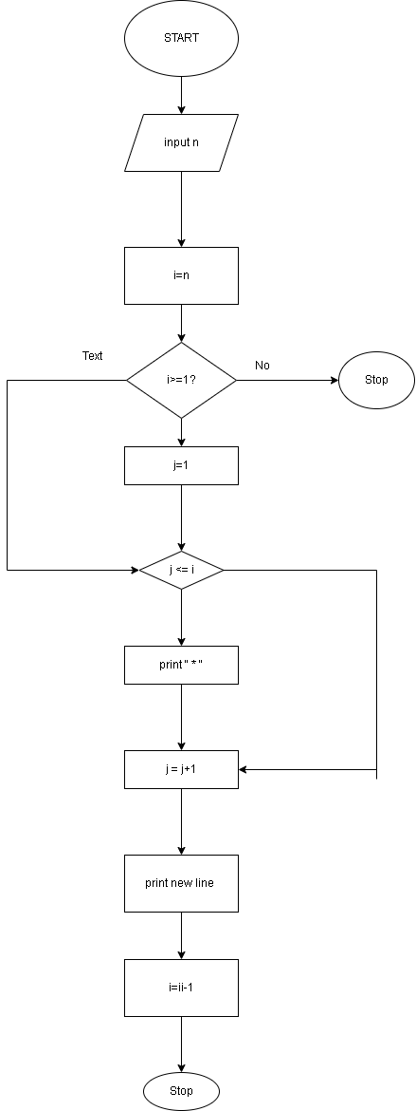

Python Code
# Type Content here...
n=int(input())
for i in range(n,0,-1):
print("*" * i)
EXCECUTION

